**Activity Space**

**(Principles of Communication)**

**Group Activity**

Discuss these scenarios.

What communication skills/ lessons can you derive from these scenarios?

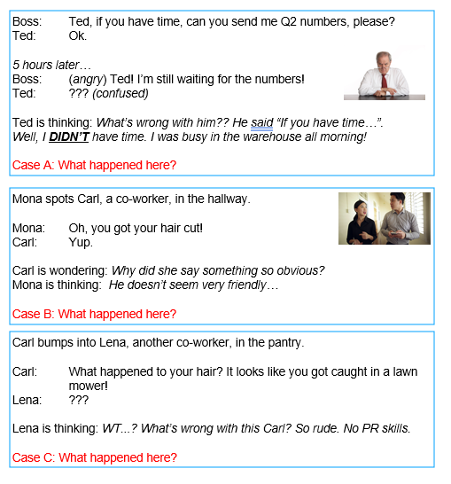

|  |  |  |  |
| --- | --- | --- | --- |
| **Room**  **(Names)** | **Case A** | **Case B** | **Case C** |
| 1  Alan  Jun Lim  Jun Leong  Shyun Yin | Boss should have been more direct if he needs it more directly. (e.g “Ok”, “if you have time”) What words did they use that were... indirect?  Both sides did not communicate when they need it by and when they can get it done.  Ted could have asked for a proper deadline (time) to submit the documents by. Indeed! | Both sides can be more open and understanding of each other's personality (introverted, extroverted).  Mona could have elaborated more and make it easier for Carl to have a follow up statement. (e.g “It looks good on you! Where did you get your haircut from”)  It's on both sides to keep the convo going. | Carl wasn’t sensitive to women by Jun Leong's personal experience.  HAHA!!!  What Carl said was not appropriate for the location and time, especially in the context of a workplace.  It is important to get to know a co-worker more to have a gauge of the limits of a person before you know what joke they can take and what they can't. |
| 2 Tai  Daryl  Wei Li  Musfirah | The boss was not being specific and too vague. “if you have time” does not mean that it is urgent and implies that it could be done at any point in time Good point! Which words specifically were “vague”?  Also the reply in one-word as “ok” can be easily misconstrued to fit the thoughts other boss hence Ted should also be mindful to be more specific in his replies. | Mona was trying her best to be friendly. She should say something open-ended for Carl to continue the conversation, like asking where he got his haircut or elaborate on where she got her haircut etc...  Some people may perceive Carl’s answer as being not friendly, one-worded answers may imply rudeness or uninterest. | Carl is trying to joke but maybe both of them are not close enough yet so Lena perceives it as something rude....  Lena should play along and reply something gritty. Haha good point there but only if a person’s character is strong enough to do so (I'd say).Or if Lena really does not like it, just be straightforward and say it. |
| 3  Wraine  Tuan  Yu Zhong  Anvitha | Time Urgency. Making assumption (“if have time”). Good point here. Can you find out where the assumption was in the dialogue? The boss implicitly required Ted to prioritize his order by using the word choice of “if have time”. Different working style. | Mona is trying to make small talks. It is being misinterpreted as a stupid question.  (Maybe common projects/ past projects they worked on) good!  Carl maybe expecting to have deeper conversations rather than superficial topics.  What are good conversational topics? | Carl is explicitly offending Lena about her appearance. Ya man  Unaware of how to transition from a friendly tone to a professional tone one to speak to others.  Carl is not tactful in describing the hair.  (Totally )  (Good inference below) Miscommunication because Carl thinks they are friends, but Lena doesn't think so |
| 4  Sharif  Haziq  Edward | Miscommunication betw boss and ted. Unclear instructions yes! (what exactly?) and unclear response from ted  The boss instructions were unclear as he did not specify the importance of the required information.  Ted on the other hand should have asked his boss when he required the numbers and let him know in advance that he would have a busy morning in the warehouse | There is some misunderstanding of the intentions in Mona’s qn. Mona and Carl might have different personalities. Mona could have asked a much more general qn like “How’s your day” instead of making a random statement. Lovely!She could have added a compliment to the statement ie “that’s a nice haircut” | Carl begins talking with Lena by being very explicit about what he thinks Lena’s hair is currently. He is not considering Lena’s current feelings like she might not have had a good day or had something bad happen recently.  Carl and Lena might not be as close as he thought they might be to make such statement as a joke either.  Carl should have kept his opinion to himself if it was not going to be constructive or complimentary. |
| 5  Braden  Aileen  Emily | They misunderstood each other. The reply was unclear (how would you make it clearer?), the boss and Ted have different interpretation of the reply.  (good point of view) Ted should have reply to the boss with longer sentence, explaining what he is working on and when he can deliver the item, instead of a short OK. The boss should have also told Ted about the urgency of the task. | Mona trying to make conversation with Carl but Carl does not get Mona intention.  Both of them should take notice of the other’s body language. Carl could have noticed that Mona wanted to be friendly.  A better choice of conversational topic could be used. Such as asking about Carl's weekend or his day at work. | Carl's comment is harsh and not nice. The comment can hurt Lena's feelings.  Carl should get to know Lena better before making such comments. Or Carl could have phrase it in a nicer way. Maybe by not exaggerating the comment, he would come across as more pleasant? |

Fantastic! Please discuss Cases A B and C and write your ideas in the table.

**Competing Values Framework**

**CVF Framework**

**Competing Values Framework**

Using the CVF framework, rate each communicative task.

1. Printer Manual
2. Communicating with the Press after an industrial accident
3. Negotiating with suppliers/vendors for a new contract
4. Pitching a new project idea to higher management for support

|  |  |  |  |
| --- | --- | --- | --- |
| **Rm** | **2. Press (after industrial accident)** | **3. Suppliers/vendors (for a new contract)** | 1. **Higher Management (for support of a new project idea)** |
| **1**  Alan  Daryl  Jun Lim  Yu Zhong | Relational – Empathetic, to change the mindset of the public through the press, and to also show that support can be given to the victims of the accident.  Transformational + Promotional-  Provide aftercare on how they can improve and prevent such accident from happening again. The first part might be under relational though. The second part.. Hmm... maybe promotional/ transformational  Informational + Relational -  Provide all the necessary detail to the public, else public will think that the company is withholding information and trying to sweep the carpet. Being candid and upfront so show that the company can be responsible for the incident | Promotional – trying to advertise the potential profits so that the suppliers/vendors will be more inclined to agree on a new contract  Informational – Both parties of the potential contract would want to obtain as much information as possible to be clear about the contract and to able to make an informed decision that would benefit both sides.  Relation – The way they communicate to each other and negotiating their idea and purpose to each other. | Transformational – We want to be able to convey to higher management that the new project idea is revolutionary, innovative, and transformative, and it is a good opportunity to bring the business up to greater heights.  Informational – Need to explain the details of the project like how it’s going to work, who is the target audience and how the project is going to be implemented.  Promotional – A call for action will be necessary after persuading for an approval of the new project. A project pitch also falls under this aspect  Relation- The need to communicate with the higher management will have some relation aspect inside. |
| **2**  Musfirah  Anvitha  Tai  Wraine | Relational – have to be credible, empathetic  Informational – to provide actual recount/details regarding the accident so that the public is well-informed  You might want to place empathy here under “relational”  Transformational is more like... steve jobs – a new innovative idea, a way to change the world etc. | Relational - Build new partnerships, need to be plausible and believable  Promotional – need to stimulate interest in the new contract, decisive and conclusive  Informational – e.g. contracts, how you execute | Promotional – Convincing the higher management the idea is plausible and beneficial to the company  Transformational – to convince the boss regarding the new idea  Informational – Give the big idea in a organized manner and have to be clear and focused in what you are pitching  Relational – so that the client can relate to the issue/problem, so you seem credible |
| **3**  Edward  Braden  Aileen  Shyun yin | Relational (Provide support for victims/family)  Information (explaining causes and effects)  Promotional (providing actionable steps after the accident these steps may still be informational- however, the message behind the steps e.g. “we are focused, we are structured, we are well-organised" might be the promotion / thing to elevate their reputation) | Relational (Building a partnership with the vendor/supplier)  Informational (information about the contract)  Promotional (Convincing supplier/vendors to sell/use their products)  Transformational (strongly worded to show how we will use their products) | Transformational (Selling new project as revolutionary)  Relational (Providing a believable idea)  Informational (info about the idea...)  Promotional (show creativity and engage the higher management to let them be absorbed into the project and its outcomes) |
| **4**  Sharif  Jun Leong  Wei Li | Relational - To build credibility with the press  Informational – There’s a need to present the facts of the incident clearly to the public looks fine! | Information – Explain to stakeholders what you can bring to the table  Relational – Building partnerships that benefit each other  Promotional – Being convincing to seal the deal | Transformational – There is a need to convince the higher management that the pitched idea brings great long term benefit.  Relational – To garner support from higher management.  Promotional – Pitches have to be engaging, show your passion and belief in the project to the management. |
| **5**  Haziq Tuan Emily | Relational – Need to use a nicer tone to relay information since it is regarding an industrial accident, and many might be affected by it yes!  Informational - Provide the facts and details of the accident | Promotional – How they are different from others.  Relational – Must be credible so that people can trust the company.  Informational - Relay the appropriate contract details to the suppliers/vendors such that there is little ambiguity in the contract | Relational - In order to get support from the higher ups, the project needs to be something plausible; not overly ambitious.  Informational- There must be enough information about the project for the boss to decide  Transformational – New ideas, new selling point.  Promotional - Must be creative and unique to gain the support of the higher management. |

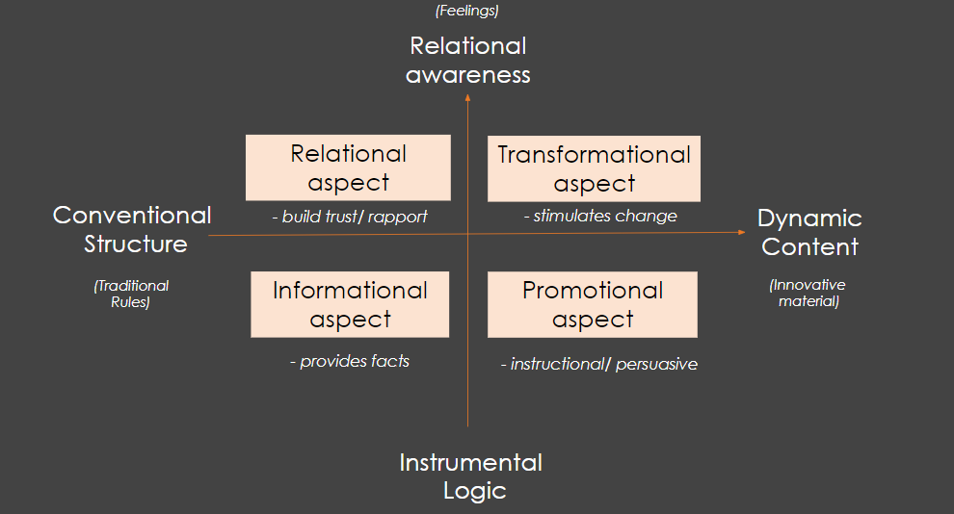

**Strategic Needs Analysis**

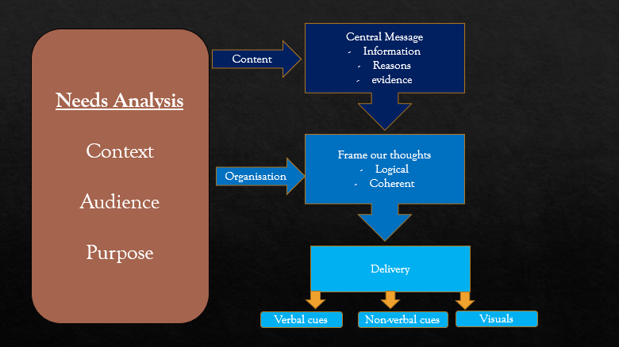

**Preparation for the next session**

Think about an industry that interests you. (It could be tech related or non-tech related.)

Find out more about the industry trends and choose one to share about in our next session on “Thinking on your feet”.

You can use the following sites.

* <https://www.pwc.com/gx/en/industries.html>
* <https://www.strategyand.pwc.com/gx/en/insights/industry-trends.html>
* <https://www2.deloitte.com/us/en/industries/technology-media-and-telecommunications.html?icid=top_technology-media-and-telecommunications> (You can also go to “Industries” or “Services” to find out more)
* <https://www.mckinsey.com/> (You can go to “Industries”, “Functions” or “Insights”)